Phonics at St Thomas More’s Catholic School
Intent:
At St. Thomas More’s, we believe that all children can learn to read, regardless of their background, needs or abilities and we are determined to make this happen. We have adopted a rigorous, systematic synthetic phonics (SSP) programme called Essential Letters and Sounds to teach encoding and decoding that includes well-conceived and structured resources for teaching phonics. This enables all children to make sufficient progress to meet or exceed age-related expectations. We have built a team of expert teachers who know and understand the processes that underpin learning to read, and draw on expert training, practice and coaching to achieve this. Our teaching of phonics shows clear consistency throughout the school and shows fidelity to our chosen programme – Essential Letters and Sounds. This therefore reduces the cognitive load on children during lessons which enables all children to make rapid progress. We ensure that ongoing assessment of children’s progress in phonics is sufficiently frequent and detailed to identify those who begin to fall behind, and provide targeted support immediately. We make efforts to involve families in supporting their children’s reading.
Where we currently are:

Our school is in our second year of our new SSP. We follow the progression sequence of GPCs shown in ELS.
Our phonics teaching begins in our Nursery where they teach phase one daily for up to 10 minutes which explores sounds, body percussion, rhythm and rhyme. Reception begin phonics swiftly in the autumn one once base line assessments have been made in line with the EYFS Curriculum. They begin with phase 2 and consolidate phase 1 to ensure they are secure. Lessons at the start of the year are 15-20 minutes long daily and progress to 25/30 minutes by then end of the year, in addition to reading and writing sessions. By the end of the year we expect most children to be secure in phase 2/3 and a large part of phase 5.
In KS1, children receive daily 30-minute phonic sessions. This is in addition to handwriting, reading and writing sessions. We use an assessment tool called Phonics Tracker half termly to identify progress and gaps to inform future teaching and support. This tracker is also used in Reception, and KS2 where needed. This means that quick revisits can be made if necessary and adjustments in the lesson can take place for ‘quick catch up’.
In Reception and KS1 we use a range of specific phonic level texts for children to practice and develop their fluency skills through a ‘3 reads’ approach. These texts are changed weekly and children are moved on only when secure at segmenting and blending rapidly in that set of books.
In addition to our phonic level books, we send home book banded texts for ‘shared reading’ opportunities to support comprehension and exposure to higher level vocabulary and common exception words. This is something we feel as a school is important in children becoming highly skilled readers. These books are sent home based on the children’s ‘benchmarked’ reading level.
Reception and KS1 phonics interventions happen regularly during mornings or afternoons which focus on quick revisits and extra opportunities to encode and decode. The lowest 20 per cent of readers are being monitored closely throughout the school. We are using Phonics Tracker at least half termly to track progress. Children who do not pass their phonic screening test will be closely monitored and interventions will be put into place to ensure a secure knowledge is achieved. KS2 use Rapid Reading and phonics trained staff members to support our lowest 20% of readers (including those that have failed the Year 1 Phonics Screening Check). Those who still require Phonics receive interventions x3 times a week led by the class teacher or HLTA. They will be monitored closely, along with the lowest 20 per cent of children to ensure progress is being made.
Implement:
What we want this to look like?
- A 20/30 minute phonic session every day, with this taking priority, unless on a school trip or involve in a key school event, in EYFS and Year 1.
- Assessing phonics daily, weekly and half termly for all children being taught phonics
- Half termly assessments through the use of phonics trackers to identify gaps and progress
- Booster small group or 1:1 phonics to take place at least 3 x weekly in EYFS and KS1 where necessary to help children to stay on track and keep up - ‘Phonics Blast!’ (oral blending, graphemes and blending for reading)
- Small group phonic sessions in KS2 to support any children not secure in phonics, as well as other interventions such as Rapid Reading. To be taught by a teacher x3 times a week.
- Holding a parents’ meeting to inform them about the teaching of phonics and the reading – this will be also accessible on our school website – Autumn 2023. One for EYFS and one for Key Stage 1.
- Holding a parents’ meeting for our lowest 20% of readers to help parents to understanding the skills their children are being taught and how they can help practice and consolidate at home.
- Offering extra reading time through a breakfast reading Café and reading support during our after-school club sessions to our lowest 20 per cent readers – to be developed 2023-2024.
- Children’s phonics reading book will have the sounds and words that they have recently been taught and will recap previously taught GPCs. They will be practiced in school three times before being sent home.
- Children’s phonics books will be used by parents to practice the child’s fluency skills.
- Children’s book banded book will be used by parents to ‘shared read’ with children to develop good levels of comprehension and exposure to other vocabulary.
- Guided reading books will be used once children have completed the ELS scheme/or if a group of children are greater depth, highly fluent readers already (to re-enter at turquoise independent book band level). This will happen once they have become fluent readers and are ready to explore comprehension more deeply.
- All staff responsible for leading and teaching phonics and reading will take part in the professional development for the school’s chosen phonics programme.
- The phonics programmes we use for catch-up provision, as for beginner readers, will be an SSP programme. We consider age appropriate programmes that are not specifically designed for younger children to enable older pupils, who are still at the earliest stages of learning, to engage with the programme and materials with high levels of motivation.
- Each pupil receiving extra support is profiled to identify any special educational needs or disability (if not already identified); any speech, communication and language needs; their attendance; time at the school, and previous teaching.
- Regular mock screenings to happen in the run up to the Phonics Screening Check to ensure all children are on track to pass.

Impact:

By the time children leave Nursery they are:
- Reach ARE for speaking and listening.

By the time children leave EYFS they are:
- Beginning to be confident decoders and blenders.
- Confident in their phonics and know all of phase 2 and 3 sounds as a minimum. They will know how to segment and blend a range of vowel consonant words from phase 2/3 and 5.
- They will know how to read set 1 - 10 Harder to read and spell simple words.
- Read and spell a range of simple sentences
This early and secure knowledge will help us to reach at least 85% in the Year 1 Phonic Screening Test.

By the time children leave Year 1:
- 80% of them will have passed their Phonic Screening Test.
- Confident in their phonics and know all of phase 2/3 and 5 sounds as a minimum. They will know how to segment and blend a range of vowel consonant words from phase 2/3 and 5. They will recognize different pronunciations of graphemes. They will know the alternative spellings of phonemes.
- They will know how to read all 13 sets of Harder to read and spell words and be able to spell the first 10 sets.
- They will be able to read and spell an increasing range of sentences involving all phase sounds and key words, sometimes using the wrong grapheme (e.g. ow instead of ou).

By the time children leave Year 2:
- 90% of children will pass a retest of their Phonic Screening Test.
- They will be confident in all phases and know all alternative spellings and pronunciations.
- They will know how to read and spell all 13 sets of our Harder to read and spell words and know the Year 2 common exception words.
- They will be able to read and spell a wide range of sentences involving all phase sounds and key words.

By the time children leave Year 6 they will:
- Be confident in using all of their phonics to spell and read complex words.
- Use all of the skills taught in KS1 to be successful competent readers.
- With a strong start in Reception and year 1, pupils’ word reading and spelling rapidly become more accurate and automatic. Teachers can then spend more time developing pupils’ reading comprehension and written composition.

Essential Letters and Sounds GPC Progression
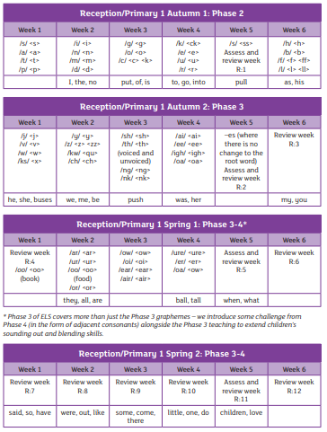

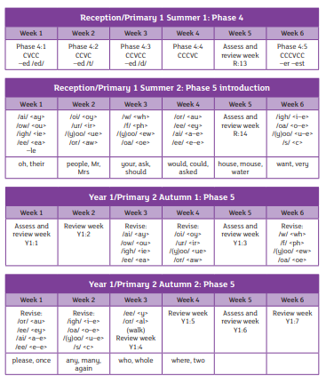

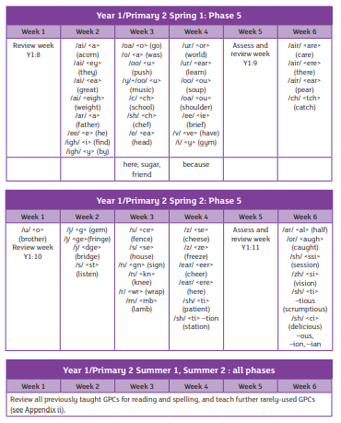

Harder to read and spell words:



